1. How often do you play AGS games?
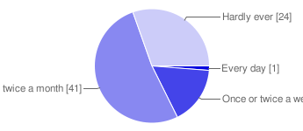
  Every day |  | 1 | 1%
  Once or twice a week |  | 13 | 16%
  Once or twice a month |  | 41 | 52%
  Hardly ever |  | 24 | 30%

2. How do you choose which games to play?
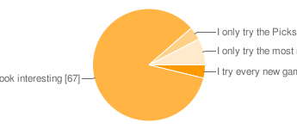
  I try every new game |  | 3 | 4%
  I browse the Completed Games board and pick games that look interesting |  | 67 | 85%
  I only try the Picks of the Month and Award winners |  | 3 | 4%
  I only try the most renowned professional games |  | 6 | 8%

3. How important are the panel ratings (the 1-5 blue cups system) for you?
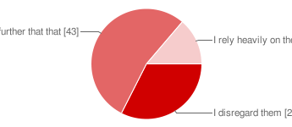
  I disregard them |  | 26 | 33%
  I generally avoid the 1-cup games, but I don't let the ratings govern my decisions further that that |  | 43 | 54%
  I rely heavily on the ratings and only play games above a certain level |  | 11 | 14%

4. Which is your favourite game setting?
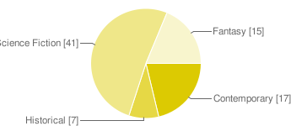
  Contemporary |  | 17 | 21%
  Historical |  | 7 | 9%
  Science Fiction |  | 41 | 51%
  Fantasy |  | 15 | 19%

5. Which is your favourite game genre?
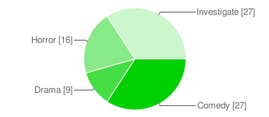
  Comedy |  | 27 | 34%
  Drama |  | 9 | 11%
  Horror |  | 16 | 20%
  Investigate |  | 27 | 34%

6. How important is the plot of the game?
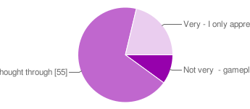
  Not very - gameplay, puzzles, humour etc are more important aspects |  | 8 | 10%
  Quite - I want a story that is consistent and thought through |  | 55 | 69%
  Very - I only appreciate games that are highly plot-driven and have high literary qualities |  | 17 | 21%

7. How important are puzzles?
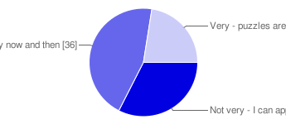
  Not very - I can appreciate games that are mostly dialogue-driven or cinematic |  | 26 | 33%
  Quite - I need a good puzzle every now and then |  | 36 | 45%
  Very - puzzles are fundamental to adventure games, and must be logical and innovative |  | 18 | 23%

8. How important is it that the game features innovative and complicated scripting?
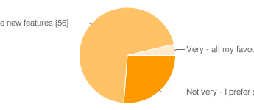
  Not very - I prefer simple, traditional interaction |  | 21 | 26%
  Quite - it's good if the game can present some new features |  | 56 | 70%
  Very - all my favourite games feature innovative and complicated scripting |  | 3 | 4%

9. How important is the game art?
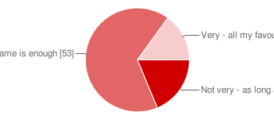
  Not very - as long as you know what you're looking at |  | 15 | 19%
  Quite - a typical Yahtzee game is enough |  | 53 | 66%
  Very - all my favourite games have beautiful graphics |  | 12 | 15%

10. Regardless of genre, what demands do you have on the level of realism?
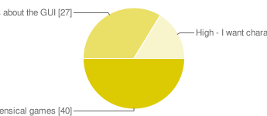
  Virtually none - I can enjoy whacky, nonsensical games |  | 40 | 50%
  Moderate - as long as the game doesn't break the fourth wall or make meta-jokes about the GUI |  | 27 | 34%
  High - I want characters and dialogue with a certain depth and credibility |  | 13 | 16%

11. What is your opinion on AGS games that turn commercial?
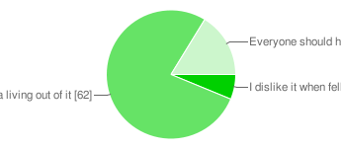
  I dislike it when fellow AGS members demand money for their games |  | 5 | 6%
  It's understandable if they have invested a lot of money in their projects, and make (or plan to make) a living out of it |  | 62 | 78%
  Everyone should have a go at making a buck on their creations |  | 13 | 16%

12. Have you ever bought an AGS-produced game?
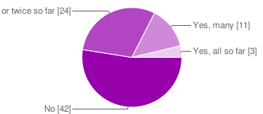
  No |  | 42 | 53%
  Yes, once or twice so far |  | 24 | 30%
  Yes, many |  | 11 | 14%
  Yes, all so far |  | 3 | 4%

13. If yes, did your latest game purchase meet your expectations?
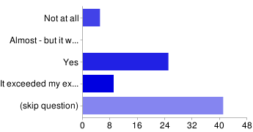
  Not at all |  | 5 | 6%
  Almost - but it wasn't really worth the money |  | 0 | 0%
  Yes |  | 25 | 31%
  It exceeded my expectations - I would gladly have paid more |  | 9 | 11%
  (skip question) |  | 41 | 51%

14. Have you ever created a game of your own (not just helped someone but been the main author)?
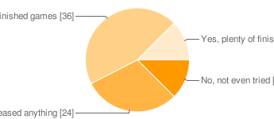
  No, not even tried |  | 10 | 13%
  I've tried but never released anything |  | 24 | 30%
  Yes, one or two finished games |  | 36 | 45%
  Yes, plenty of finished games |  | 10 | 13%

15. If yes, what aspect of the production did you find the hardest?
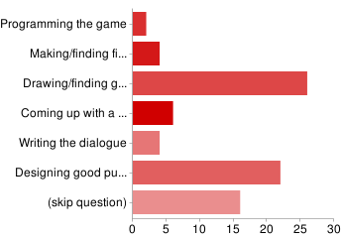
  Programming the game |  | 2 | 3%
  Making/finding fitting sound & music |  | 4 | 5%
  Drawing/finding good graphics |  | 26 | 33%
  Coming up with a good story |  | 6 | 8%
  Writing the dialogue |  | 4 | 5%
  Designing good puzzles |  | 22 | 28%
  (skip question) |  | 16 | 20%

16. If you have been - or were to be - part of a production, what was/would be your main strength?
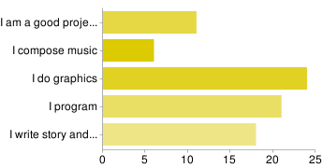
  I am a good project leader |  | 11 | 14%
  I compose music |  | 6 | 8%
  I do graphics |  | 24 | 30%
  I program |  | 21 | 26%
  I write story and dialogue |  | 18 | 23%

